# Post-Truth Design Tactics in Memes in India: Decoding Malicious Design Practices in Right-Wing Meme Factories By Aarushi Bapna, Ajitesh Lokhande

On May 12, 2017, two people suspected to be child kidnappers were lynched in the Indian village of Jadugora, in the eastern state of Jharkhand. The panic and fear that eventually led to this lynching can be traced back to a series of WhatsApp forwards that were being widely circulated in the state. These messages included pictures showing dead children and warned about so-called ‘child lifters’. The May 12 lynching was one of several that were about to follow all across the country. This incident was one of the first major stories covered by Indian media about the real-life consequences of viral online content.[1]

When the Oxford Dictionary chose ‘post-truth’ as its word of the year in 2016, the waves of global post-truth politics had just begun to ripple out. Now in 2021, we have been hit by multiple tsunamis of events whose triggers can be traced back to post-truth politics: the insurrection at the United States Capitol weeks before the inauguration of the new president; anti-mask demonstrations worldwide;[2] conspiracy theories regarding COVID-19 being a hoax; and the Indian government’s nation-wide social media campaign targeting one specific celebrity (Rihanna).[3]

But while post-truth politics is a complex and layered concept from a socio-political perspective, it might be helpful to narrow our cone of vision and try to look at it from a visual design lens. One of the easiest ways to look at its impact on our daily lives might be to look in memes. Much has been written about memes from a cultural, ideological and quantitative perspective,[4] but visual design analysis seems sparse.

India’s rich visual vocabulary of signs and symbols, emerging from its culture and history, have found their way into memes. Being avid meme enthusiasts and having been trained as visual designers in India, we went down the algorithmic rabbit hole of Hindu Right-Wing memes and conducted a qualitative analysis, to highlight visual design techniques used in their propagation.

## Indian Political Scenario

### Ruling Party Powered Meme Factories

In India the Overton Window has long shifted, transforming the former *political right* into the *center.* [5] Recent polarizing events like the CAA-NRC and the farm-bill protests have contributed to this shift in perception. The Bharatiya Janata Party (BJP) is the current ruling political party heading the Indian government. This party has become infamous for its information technology wing known as the *IT Cell*. They have a vast network of paid workers and volunteers who manage the party’s online presence and digital outreach. This management has often included the creation of bot accounts and starting Twitter trends, among other questionable practices like spreading fake-news and performingsocial engineering.[6] They reportedly mobilized 50,000 WhatsApp groups to reach about 200,000,000 voters in a single state election.

During one political rally by the ruling party, one of the leaders ofBJP’s IT Cell (a sitting cabinet minister) boasted of their capacity to deliver any ‘any message we want to the public, whether sweet or sour, true of [sic] fake.[7] The political establishment is not only aware of this culture of fact-denying, disinformation, and post-truth politics, but occasionally it even takes part in it.

To fully understand the context of fake-news in India, one needs to understand a phenomenon that is a more evolved form of sensationalism. This phenomenon is planned, designed to grab attention, appeal to emotion, and set trends for political discourse. This is where the *Aestheticization of Politics* comes in.

## Memes as Aestheticization of Politics

In his essay *The Work of Art in the Age of Mechanical Reproduction*, Walter Benjamin mentions the ‘Aestheticization of Politics’. This is when effective democratic governance is sidetracked and focus is shifted to sweeping, grand political gestures [8]. The result is an emotionally appealing, ‘aesthetic’ narrative that often hides objectively cruel violence behind it, or even glorifies it. Looking to India, we can findan example of aestheticized political acts in Modi’s reframed narrative of reuniting the abandoned state of Kashmir with the rest of India. Contrary to this narrative, in fact the state was annexed by overriding constitutional parliamentary procedures. This nation-unifying narrative seems to contain a ‘*kernel of truth*’, but one distorted and buried beneath its political aestheticization.[9]

In this example, the actions are such that they sound appealing in theory and in their storytelling. But this grand storytelling hides the actual inefficiency and authoritarian nature of the actions themselves. Walter Benjamin describes the ‘aestheticization of politics’ generally as enacted by politicians and artists (e.g. Futurist Art that glorifies war and violence as beneficial to human development).[10] The medium of the meme makes this practice of aestheticizing politics and violence accessible to any person with an internet connection.

### Types of ‘Aestheticization of Politics’

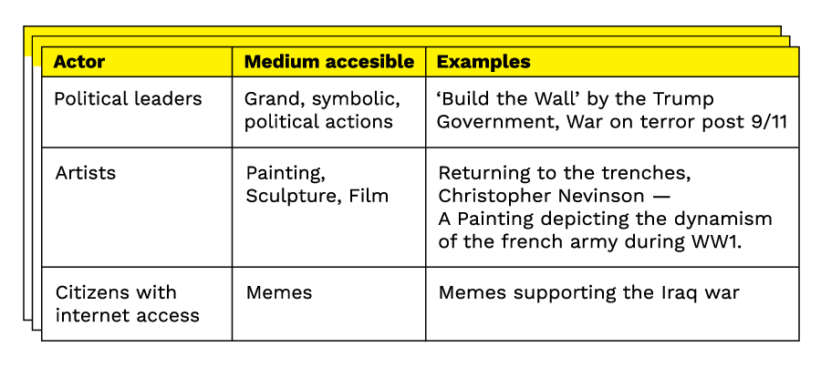  
Fig. 1 Types of Aestheticization of Politics

Today, the paradigm shift to be considered is the emergence of memes as an extremely accessible tool of aestheticizing politics (e.g. Hello Kitty says ‘ACAB’,[11] Lindsay Graham DGAF memes,[12] Apply Burnol memes celebrating right-wing political achievements [13]).

## Decoding Memes

The nature of propaganda is overtly visible in traditional media—advertising, political murals, speeches, etc. However, it is more covert on social media in the form of memes. The Indian right-wing seems to borrow heavily from various propaganda techniques that have been used by many fascist governments as well as corporate companies, These vary from the *ad nauseam* rhetoric of a Hindu Rashtra*,*[14]flag-waving of saffron Hindutva symbols, or the constant use of logical and informal fallacies. These tactics naturally find their way into online communication. Various actors co-opt visual design to extend these tactics to apparently harmless memes. Lisa Bogerts and Maik Fielitz argue that, as political tools, ‘memes combine a variety of stylistic and aesthetic strategies and visual tools to appeal to multiple audiences, and still convey messages in line with their core ideological far-right beliefs’.[15] In the same study, they also state that ‘Since the far-right, too, has undergone a process of (post-)modernization, it must be regarded as closely intertwined with post-modern (youth) cultures who express themselves creatively and often ironically on social media.’ Virality defeats veracity, and one of the key ingredients of this fact-defying virality is its visuality.

Fig. 2 One Nation One Flag.   
Source: @saffronpilled, One Nation One Flag, 2019, Instagram Post, https://www.instagram.com/p/BzA4B9cFs7W/

In the meme in figure 2, we see a combination of visual symbols. The lighting, the retrofuturist car, and the CGI 3D environment are key ingredients from the Synthwave aesthetic. The uncanny additions are the *saffron flags* (official symbol of RSS[16]), a saffron map of South and South-East Asia, and the slogan ‘One Nation, One Flag’. These are recurring symbols of the right-wing Hindu nationalist ideology. The use of the propaganda technique of repetition is apparent here.

This meme associates urban development and Hindu nationalism. The imagery used for this is highly western with skyscrapers, neon lights etc. However, the message is anti-western: that of an imperialist Hindu Nation, thus, creating a certain amount of cognitive dissonance. The idea of a Hindu nationalist empire is made more attractive to a viewer by co-opting Synthwave aesthetics. Bogerts and Fielitz make a very similar observation in the context of the German alt-right: ‘These trendy visuals make historical references less “old-fashioned” and more appealing to a younger audience and/or persons with an affinity to 80s popular culture’.[17]

Another tactic, the use of *virtuous imagery*, the rising sun in this case, is also employed. The meme visually equates the idea of the Hindu empire to a rising sun on the horizon. By using these techniques this meme efficiently presents the idea of a Hindu Nation to a young audience immersed in digital culture.

### Meme 2: Hindu Lives Matter

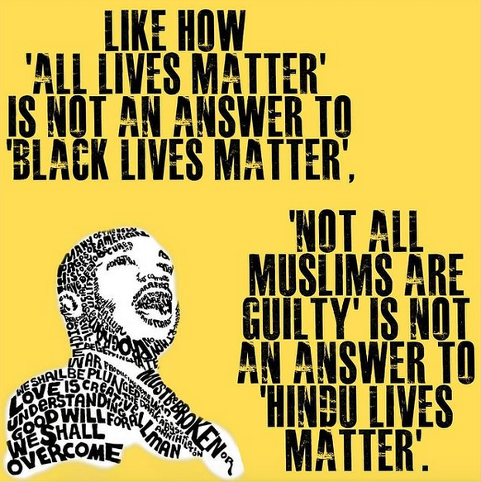

Fig. 3 Hindu Lives Matter  
Source: @bharatincrisis, Hindu Lives Matter meme, 2020, Instagram Post, https://www.instagram.com/p/CLMMSfdABK6/?igshid=1kf3pts4eyki3

In figure 3, we see yet another visual aesthetic being exploited. The visual style mimics an activist, outraged, and intellectual stance. It dissociates *Hindutva* ideology from its widely held perception of being orthodox, violent, and non-intellectual. Thus, in this imitation, we see this post exploiting the propaganda technique of trendification, whereby a trending visual style is appropriated for propaganda purposes.

The tall condensed typography with its spray-paint treatment, in black and yellow colors, are highly reminiscent of the graphics and visual language that emerged around the Black Lives Matter movement in 2020. Through imitation and transfer*,* it seeks to elicit a similar reaction of indignation from the viewer by creating a twisted and false equivalence between the systemic atrocities faced by Black people in the US, with supposed atrocities faced by majority Hindus in India. Further, the processed image of Martin Luther King Jr. and the lyrics of ‘We Shall Overcome’ hint at this false narrative of Hindu-victimization.

This particular post was released in response to the murder of Rinku Sharma.[18] It reframes ‘Not all Muslims are guilty’ as nothing but the Indian equivalent of ‘All Lives Matter’, ignoring the systemic vilification of minority Muslims. Thus, we see this post relying on a completely false equivalence to support its position.

### Meme 3: Sanskari (Virtuous) Girl meme

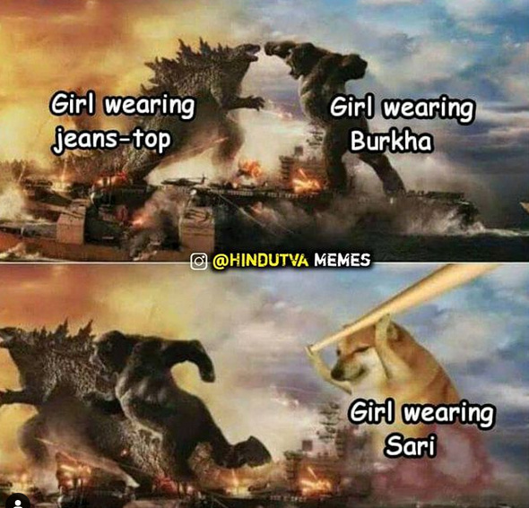  
Fig. 4 Girl wearing Sari  
Source: @hindutvamemes, Girl Wearing Sari, 2021, Instagram Post, https://www.instagram.com/p/CNt4ug6Lxd4/

Figure 4, is much less political in comparison to figures 2 and 3. It uses the well-known meme template of ‘Godzilla vs. Kong vs. Doge’. In this two-panel object labeling meme, we see Godzilla and Kong being equated to ‘girl wearing jeans-top’ and ‘girl wearing burkha’ respectively. It is helpful to know that in the Indian context, ‘girl wearing jeans-top’ is symbolic of modernism *and* Westernization. Similarly, ‘girl wearing burkha’ is a crude stereotype of the Muslim faith. ‘Girl wearing sari’ however, in a reductive symmetry, is symbolic of virtuosity.

As the Godzilla vs. Kong vs. Doge meme template is usually seen using the Arial, or Impact fonts, we can speculate that the choice of Comic Sans intends to enhance the humorousness of the meme.

By associating the positive, much-loved character of Doge with the symbol of ‘Girl wearing Sari’ (traditional attire) the meme seeks to play up Hindu cultural supremacy. We can also deduct that this remix employs the Virtuous Imagery tactic. The idea of fundamentalist Hindutva attacking western and Muslim culture is made more acceptable by associating it with a lovable character like Doge.

### The Resulting Tactics

As part of writing this article, we applied visual deconstruction and qualitative analysis to 60 memes. By comparing our analyses with documented propaganda techniques, we found the following tactics to have emerged in a visual form through memes.

### Trendification

Adapting historical and political contexts to trendy visual genres or subcultures to appeal to their respective audiences. These trends may include aesthetic styles, current events & pop culture references.

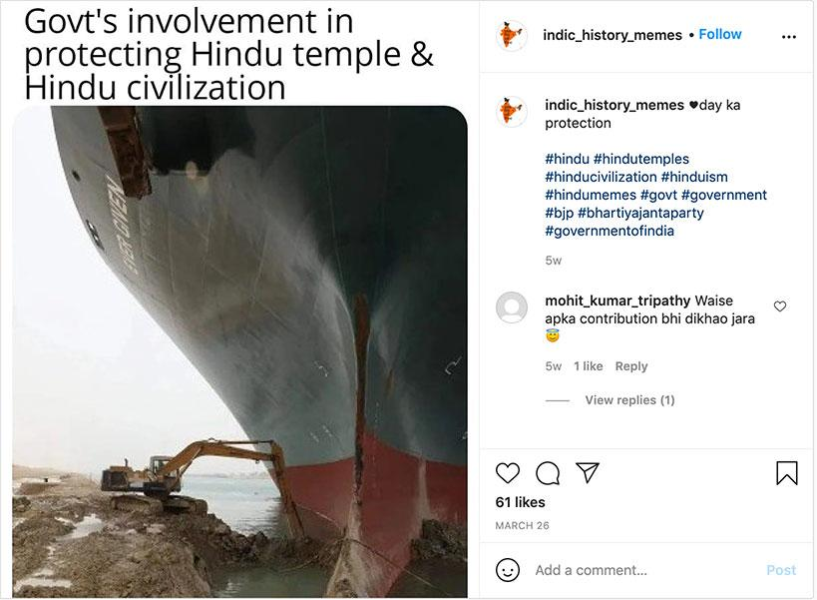  
  
Fig. 5 ‘Govt’s involvement in protecting Hindu temple and civilization’  
Fig. 5 is a reference to a ship getting stuck at the Suez Canal in March ‘21 and was a heavily used meme format. Here the messaging points at religious (Hindu) victimization even though the group is a vast majority in the country. This is a classic example of Trendification.   
Source: @indic_history_memes, ‘Govt’s involvement in protecting Hindu temple and civilization’, 2021, Instagram Post, <https://www.instagram.com/p/CM3wFp4Bl82/>.

### Virtuous Imagery

Associating an idea with positive and emotive language. Juxtaposing an ideological message with euphoric or cheerful imagery.

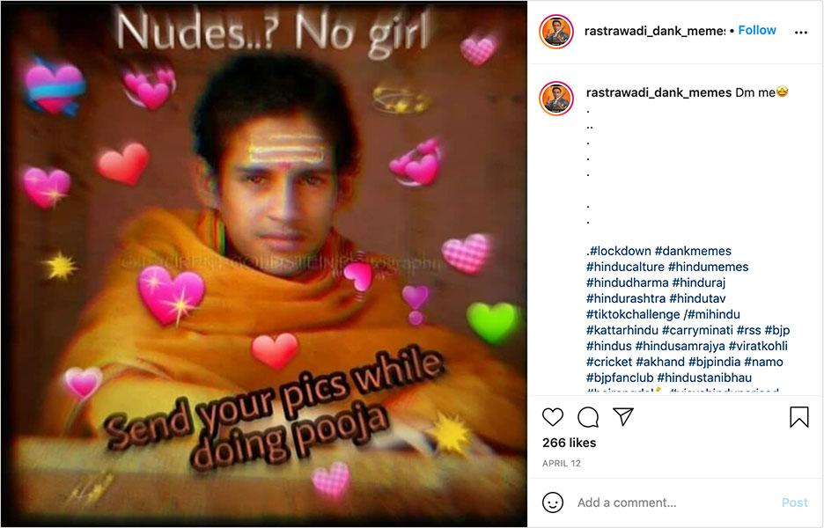  
Fig. 6 ‘Nudes…? No girl’  
The meme (fig.6) is a reference to the popular culture of sharing nudes. However, this is depicted as a ‘vice’, and doing pooja (engaging in worship) is depicted as a ‘virtuous’ act. The aesthetic used is of a popular AR filter and the imagery is of a young Hindu monk.   
Source: @rastrawadi_dank_memes, ‘Nudes…? No Girl’, 2021, Instagram Post, https://www.instagram.com/p/CNkgd-4hfxp/

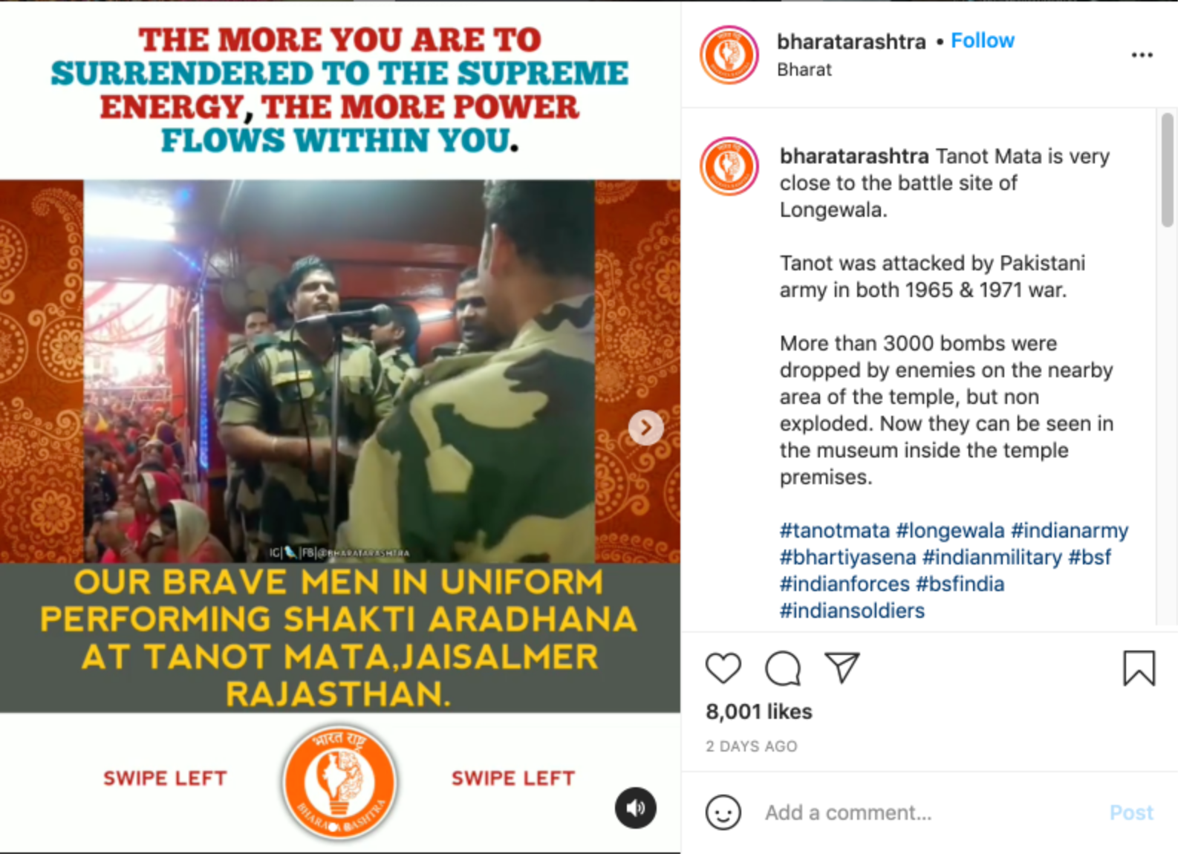

Fig. 7 Soldiers performing worship infographic  
The meme is from a popular right-wing page with over 16.1k followers. This meme consists of two ‘virtues’: those of religiosity and military patriotism. The mixed message hopes to point at how the ‘brave’ soldiers are engaging in Hindu prayer at theIndia-Pakistan border.  
Source: @bharatarashtra, Soldiers performing worship infographic, 2021, Instagram Post, https://www.instagram.com/p/CNpOeTyBij7/

### Deceptive Simplification

Using *glittering generalities,*[19] to falsely prove ideological arguments. Oversimplifying complex, nuanced realities to incite a change in viewpoint.

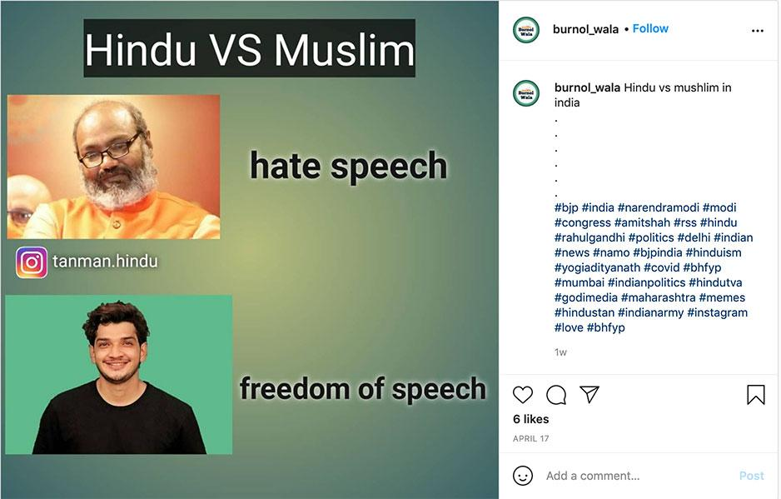  
Fig. 8 Hindu vs. Muslim reaction meme  
This meme is an example of an over-simplistic and vague comparison of two incidents. It depicts two personalities with different religious affiliations conveyed through their background colours (saffron being Hindu, green being Muslim). However, the meme is a jab at liberals and claims that in their eyes only Muslims have ‘freedom of speech’ while Hindus do not. This is a case of *Hindu-victimisation* and whataboutism.   
Source: @burnol_wala, Hindu vs. Muslim reaction meme, 2021, Instagram Post, https://www.instagram.com/p/CNxh-fjj-q8/

### Conditioning or ‘Brand Recall’

Repetitive use of symbols combined with different visual stimuli to condition a consistent reaction to those stimuli. Some recurrent Hindu Right-Wing symbols include ‘saffron flags’, the slogan of ‘Hindu Rashtra’ and hashtags like #hinduculture, #hindulivesmatter, etc.

Co-opting conventionally left-wing aesthetics (e.g. social justice slideshows on Instagram[20]) to propagate a right-wing agenda. Driven by transfer of association of the visuals they imitate, such memes establish the credibility of their content.

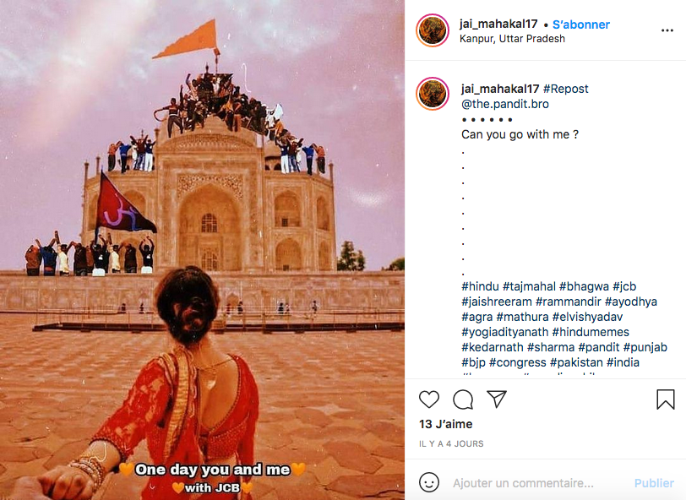  
  
Fig. 9 ‘Can you go with me?’  
In Fig. 9 the meme shows a mob climbing on top of the Taj Mahal and waving a saffron flag as a display of their domination. The meme is meant to be an attack on this monument because it was built by a Mughal ruler (the entire Mughal empire being a symbol of Islamic oppression of Hindu India according to the Hindu right-wing ideology)  
By using the recurring imagery of Hindu ideology (saffron flags) the meme tries to dissociate its gruesome context. This visual recall helps in endorsing views under the guise of subscribing to this ideology. It also uses Trendification (1) as a visual style in the form of its pink glitter filter which gives it a Tik Tok aesthetic. It’s worth pointing out the photo is a direct reference to the Insta-famous ‘hand-holding’ couple.  
Source: @jai_mahakal1, “Can you go with me?”, 2021, Instagram Post, https://www.instagram.com/p/CNsNq4YBmGW/

### Cognitive Dissonance

When the repetitive association of two conflicting ideas is employed in propaganda, people tend to either accept both ideas or refuse both of them. One recurrent approach is to associate a popular celebrity with an unpopular idea, forcing viewers to either reject the celebrity or accept the idea.

Another approach is disinformation combined with false imagery in the form of image manipulation, deepfakes etc. to create false visual association. This can also be achieved by cherry picking content.

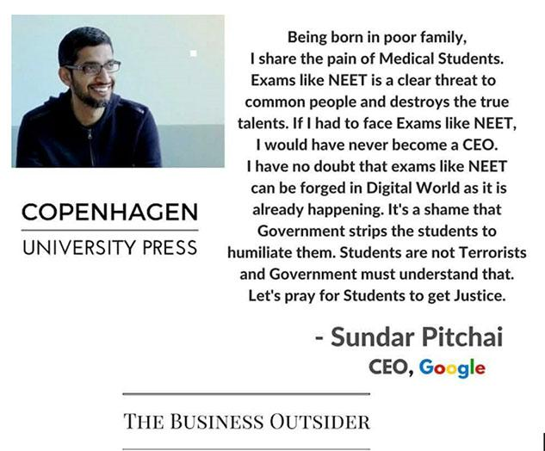  
Fig. 10 Sundar Pichai on NEET exam  
In fig. 10, we see a viral image that was being circulated to show Google CEO Sundar Pichai’s opinion on the NEET exam (a medical entrance exam in India). The image includes the logos of the *Copenhagen University Press, Google* and *The Business Outsider.* However, Sundar Pichai reportedly never said any of the given text.[21] *Copenhagen University Press* has no association with this statement either and the name and website of *The Business Outsider* seeks to emulate another much more credible and well-known website called *The Business Insider*. These three elements add a touch of legitimacy to this viral and false image.

### Red Herring & Pseudo-Scientific imagery

Memes deploying this strategy present data or issues that, while compelling, are irrelevant to the argument at hand, and then claiming that it validates the argument. Often coupled with imitation and association transfer, pseudo-scientific imagery is used to validate hoax claims and fake news. This is done through diagrams, scientific-looking visuals, made-up testimonies of projected experts, other similar techniques.

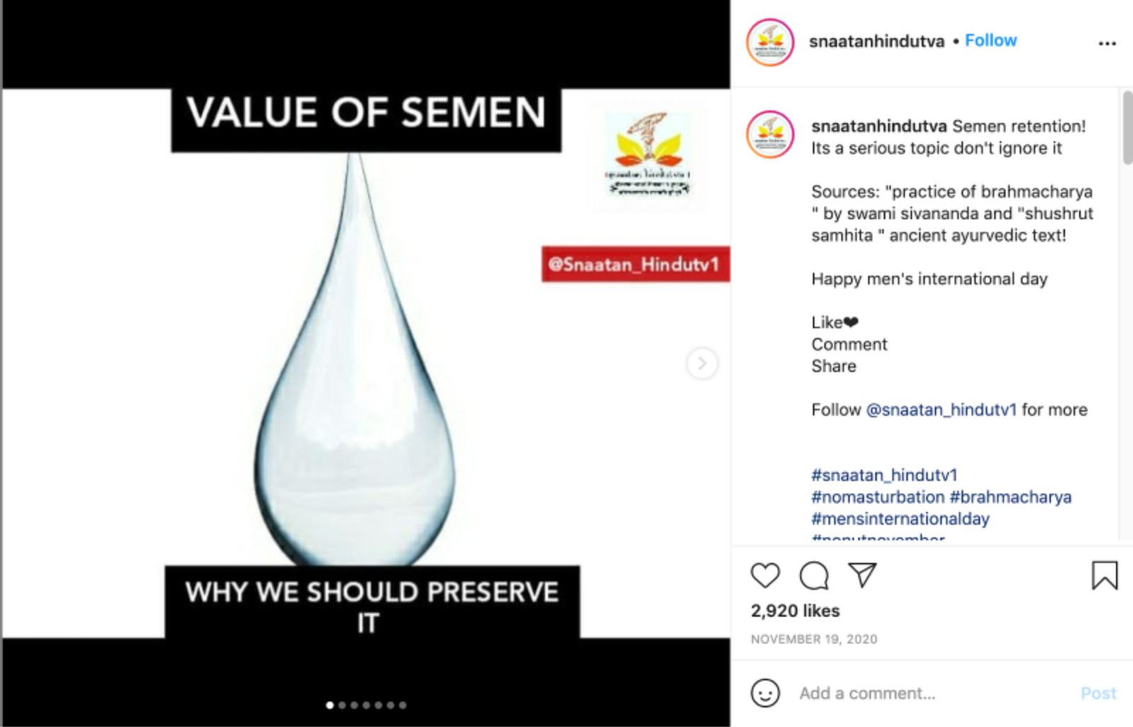  
Fig.11.1 Value of Semen

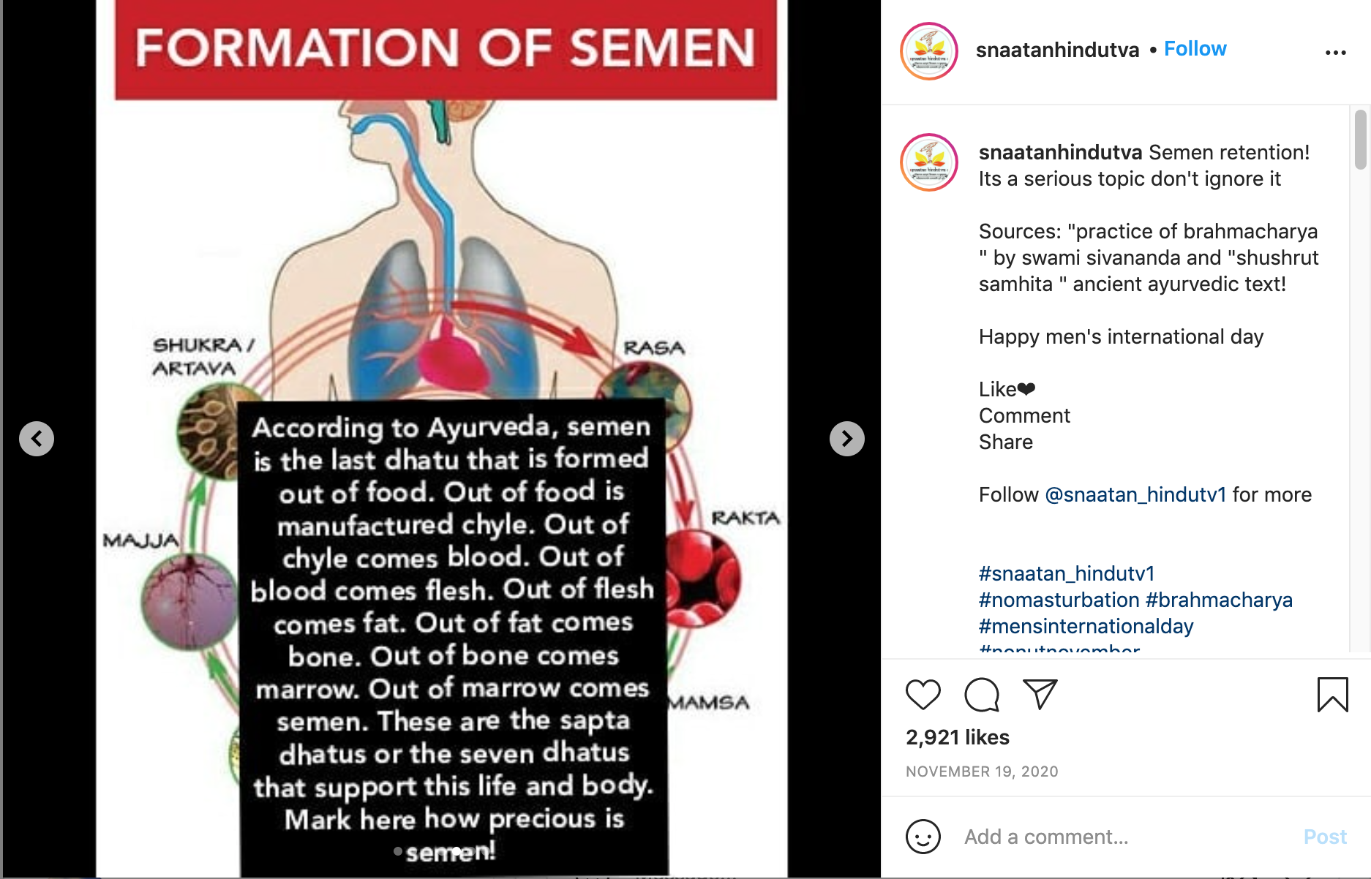  
Fig.11.2 Formation of Semen  
The Fig.s 11.1 and 11.2 are slides from a post claiming unverified facts and a hoax theory (11.1) by using anatomical diagrams (11.2) to appear scientific. The claim cites Ayurveda[22] as logic for this theory and calls to reject so-called western notions on the subject.  
Source: @snaatanhindutva, Value of Semen Infographic, 2020, Instagram Post, https://www.instagram.com/p/CHw-KnBAEJH/

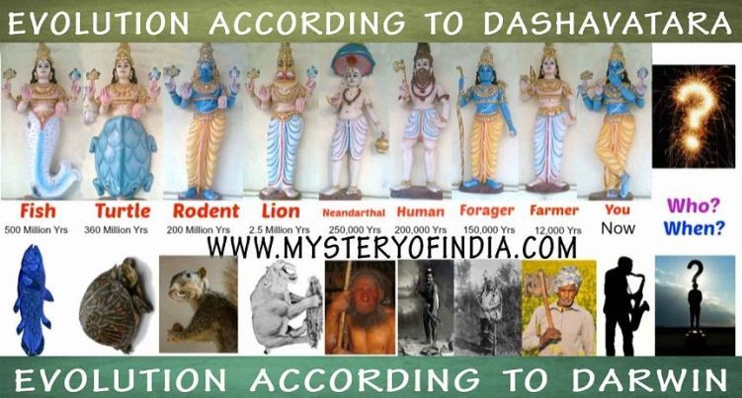

Fig. 11 Darwin x Dashavatara  
In this second example, the meme is trying to establish a supposed link between the chain of evolution and the different avatars of the hindu god Vishnu. By juxtaposing arbitrary creatures on a timeline, the meme tries to imply that the Hindu mythological concept of ‘Dashavatara’ had foretold and preceded Darwin’s theory of evolution.  
Source: Mystery of India Website, Evolution according to Dashavatara, 2014, Blog Post, https://www.mysteryofindia.com/2014/10/dashavatar-darwins-evolution.html

### Cute-ification

While this tactic may seem to overlap with Trendification, its widespread nature, excessive usage and various subgenres require the creation of a separate category. This tactic involves presenting messages embedded in cute pop cultural references. The bite-sized format of cute, aesthetically pleasing memes distances you from the grotesque facts, thereby warping your perception of reality.

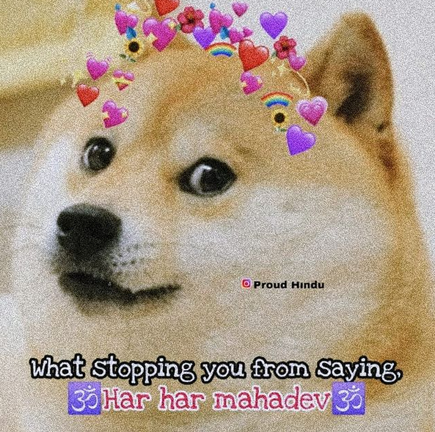  
Fig.12 Har Har Mahadev X Doge  
In the meme above, we see the character Doge asking the viewer what is stopping them from saying ‘Har Har Mahadev’– originally a religious Hindu mantra. The meme is a reference to a political speech where the phrase was used as a jab at the opposition (for having contested the use of religious slogans in politics). It undoes this political connotation by presenting it with the Doge meme and cute emojis.  
Source: @proudhindu_, Har Har Mahadev X Doge, 2021, Instagram Post, <https://www.instagram.com/p/CM2T9PRBRQL/>.

### Trivialization

The use of imagery to imply something is unimportant or not worthy of attention. Using common jokes, cartoons and rage comics to dismiss and trivialize oppressed groups, the opposition and critique.

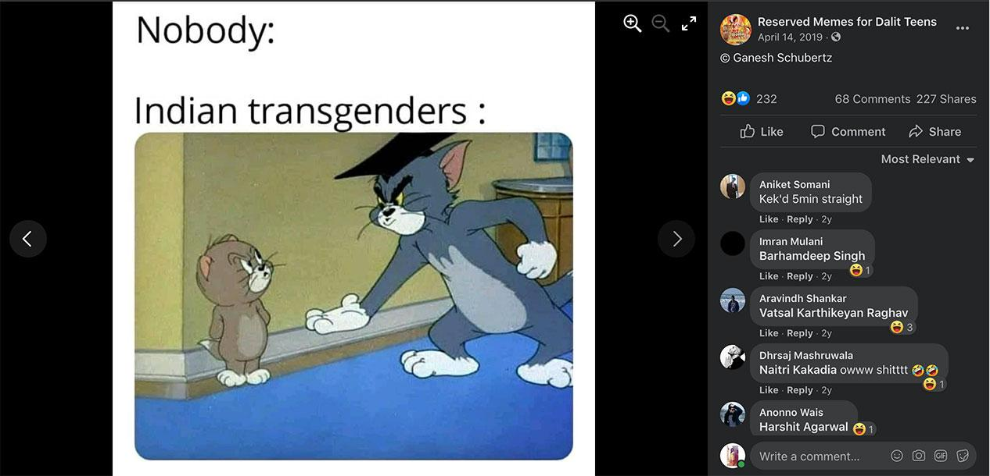  
Fig. 13 Indian Transgenders x Tom and Jerry

In this example, we see Indian transgender people being equated to the cartoon Tom, insistently asking for something. This is a jibe at transgender people who beg due to forced systemic poverty. By depicting their plight in the form of a cartoon-based meme, all nuance and attempts to understand the issue are discarded. The entire Indian transgender community is thus alienated and reduced to mere fodder for humor.  
  
Source: Reserved Memes for Dalit Teens, Indian Transgenders X Tom and Jerry, 2019, Facebook Post, https://www.facebook.com/Dalitsenpai/photos/610210472788608

## Social media strategy

It is important to point out that the potency of these visual tactics is also due to the social media management tactics that accompany them. One of these strategies involves interspersing different types of content. This consists of posting memes about a plethora of topics, with varying degrees of political commentary, sometimes completely apolitical. Through such posting tactics, one can microdose political content between lots of general, humorous internet content and get new followers to engage with the account. Another phenomenon that works in the favor of provocative visual memes is the relationship between novelty and virality on social media. A study conducted by researchers at MIT found that fake news travels faster on social media than the truth, and it is humans who are majorly responsible for this rather than bots. As the authors put it, ‘False news [is] more novel than true news,’ and people are ‘more likely to share novel information’.[23]

Finally, the crude, rapid, and easily modifiable format of memes makes them very easy to create and consume. These social media management techniques ensure visibility to a wide audience, and the aforementioned visual tactics ensure maximum impact on each of the people who make up this audience.

## Memes of Mass Destruction

The Jadugora lynching incident mentioned at the beginning of this article was one amongst several examples of the real life consequences of viral content. The gravity of the threat can be gauged from the fact that even a tech giant like Facebook fears for the security of its employees,[24] who face the genuine threat of a violent backlash for action against Facebook pages belonging to Hindu nationalist militant organizations such as Bajrang Dal.

Should we be worried when a 17-year-old (a minor according to Indian law) was motivated to pick up a loaded weapon and attack a crowd in the presence of a platoon of police officers?[25] Some might argue he was just an angry ‘protester’ but his Facebook tells a story of a young mind radicalized by malicious propaganda: the content he consumed in turn consumed him. A shocking incident, but can we really say we didn't see it coming?

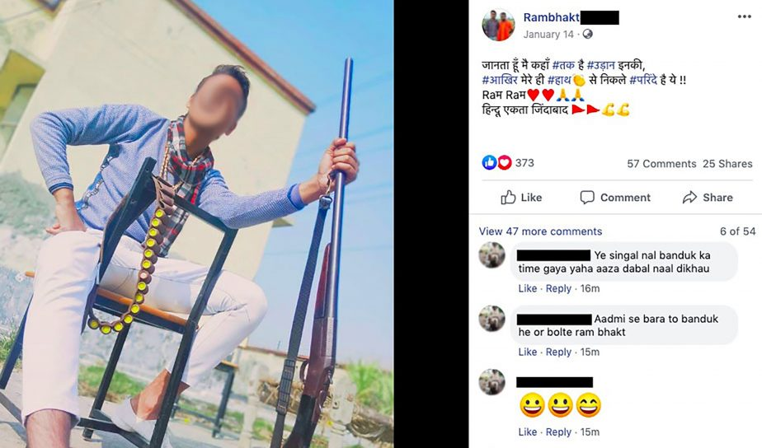  
Fig.15 Screenshot from the perpetrator’s Facebook page right before he pulled out the gun. He uses the prefix ‘*Rambhakt*’ (which translates to a worshiper of the Hindu god Ram).  
Source: Screenshot of ‘Rambhakt’s’ Facebook post, the 17-year-old shooter at Jamia Milia Islamia University is posing with a gun, 2020, News Article, https://thediplomat.com/2020/02/jamia-millia-shootout-making-of-a-hindutva-terrorist/

In Freedom House’s *Freedom in the World 2021* report, India had its status a s a ‘free’ nation downgraded to ‘partly free’ due to what they describe as ‘a multiyear pattern in which the Hindu nationalist government and its allies presided over rising violence and discriminatory policies affecting the Muslim population and pursued a crackdown on expressions of dissent by the media, academics, civil society groups, and protesters’.[26]

In the post-pandemic age, the boundaries between online and physical spaces are blurring. This fusion of space also implies the merging of battlegrounds: farmers protesting at the Tikri Border in Delhi, the blitzkrieg of hashtag trends on Twitter, anti-lockdown protesters at Museumplein in Amsterdam, QAnon militants fighting comment battles under 2021 US insurrection videos in the Youtube comment section, Redditors LOLing over a coup in Myanmar accompanied by an aerobics routine…

This surreal, entertaining, scary, and numbing juxtaposition of realities is nothing but a war between truths, and the weapons of this war are memes of mass destruction*.*[27]

## References:

Basu, Soma. “Jamia Millia Shooting: Making of a Hindutva Terrorist.” *Thediplomat.com*, February 3, 2020. <https://thediplomat.com/2020/02/jamia-millia-shootout-making-of-a-hindutva-terrorist/>.

BBC News. “Covid: Dutch CURFEW Riots Rage for Third Night.” *BBC News,* January 26, 2021. https://www.bbc.com/news/world-europe-55799919.

BBC News, “Farmers' Protest: Rihanna Tweet Angers Indian Government,” *BBC News* February 3, 2021, <https://www.bbc.com/news/world-asia-india-55914858>.

Benjamin, Walter. “The Work of Art in the Age of Mechanical Reproduction.” Translated by Harry Zohn. In *Illuminations,* edited by Hannah Arendt, 217-252. New York: Schocken Books, 2007.

Bhat, Rema. “Hello Kitty ACAB: The Aestheticization of Politics.” Www.34st.com, October 9, 2020. https://www.34st.com/article/2020/10/hello-kitty-acab-memes-prison-industrial-complex-woke-infographics.

Bhattacharya, Ravik. “Jharkhand Lynching: AMID Whatsapp Rumours, Tribals Stopped School, Outdoors for Kids,” *Indian Express,* May 22, 2017. https://indianexpress.com/article/india/jamshedpur-amid-whatsapp-rumours-stoked-fears-tribals-stopped-school-outdoors-for-kids-jharkhand-lynching-non-tribal-clash-4666068/.

Bogerts, Lisa, and Maik Fielitz. “‘Do You Want Meme War?’” In *Post-Digital Cultures of the Far Right*, edited by Maik Fielitz and Nick Thurston, 138–54. Beilefeld, Germany: Transcript Verlag, 2018. http://library.oapen.org/handle/20.500.12657/27372.

Chandna, Himani. “Good Ol’ Burnol Is Now a Twitter Punchline, but That’s far from Bad News for Its Brand.” *ThePrint*, February 21, 2019. <https://theprint.in/features/good-ol-burnol-is-now-a-twitter-punchline-but-thats-far-from-bad-news-for-its-brand/195272/>.

Clark, Jennifer. “Memes of Mass Destruction: What Do Memes Indicate about Nuclear Power Relations?.” *Contemporary Political Challenges* 1, no. 1 (2018), 234-266.

Delwiche, Aaron. “Glittering Generalities — Propaganda Critic.” Propaganda Critic, November 30, 2018. https://propagandacritic.com/index.php/how-to-decode-propaganda/glittering-generalities/.

Dhume, Sadanand. “The Dueling Narratives of India’s Kashmir Crackdown.” *The Atlantic*, September 5, 2019. https://www.theatlantic.com/international/archive/2019/09/the-dueling-narratives-of-indias-kashmir-crackdown/597457/.

Freedom House. “India: Freedom in the World 2021 Country Report | Freedom House.”2021. https://freedomhouse.org/country/india/freedom-world/2021.

Horwitz, Jeff, and Newley Purnell. “In India, Facebook Fears Crackdown on Hate Groups Could Backfire on Its Staff.” *The Wall Street Journal,* December 13, 2020. https://www.wsj.com/articles/in-india-facebook-fears-crackdown-on-hate-groups-could-backfire-on-its-staff-11607871600.

Know Your Meme. “Lindsey Graham DGAF.” October 8, 2018. https://knowyourmeme.com/memes/lindsey-graham-dgaf.‌

Milosavljevic, Ilija. “The Phenomenon of the Internet Memes as a Manifestation of Communication of Visual Society: Research of the Most Popular and Common Types.” *Media Studies and Applied Ethics* 1, no. 1 (March 2020): 9-27

The News Minute. “Sundar Pichai Is the New Bad Meme: 'Quotes' That the Google CEO Wouldn't Have Dreamed of Making.” June 2, 2017.   
https://www.thenewsminute.com/article/sundar-pichai-new-bad-meme-quotes-google-ceo-wouldnt-have-dreamed-making-63046.

Nguyen, Terry. “How Social Justice Slideshows Took over Instagram.” *Vox*, August 12, 2020.  
https://www.vox.com/the-goods/21359098/social-justice-slideshows-instagram-activism.

Pandharipande, Neerad. “Massive Tweet Volumes, Complex Hierarchies, Coordinated Attacks: Hacker Reveals How BJP, Congress IT Cells Wage War on Social Media.” *Firstpost*, January 28, 2020. https://www.firstpost.com/india/massive-tweet-volumes-complex-hierarchies-coordinated-attacks-hacker-reveals-how-bjp-congress-it-cells-wage-war-on-social-media-7965121.html.

Ram, Rohit. “When Art Imitates Death: A Look at Contemporary Aestheticized Politics.” *The World Mind*, October 26, 2020. https://www.theworldmind.org/home/2019/10/26/when-art-imitates-death-a-look-at-contemporary-aestheticized-politics.

Singh, Swadesh, et al.. “Indian Liberals Don't Get the Difference between Hindu State & Mohan Bhagwat's Hindu Rashtra.” *ThePrint*, October 4, 2019. https://theprint.in/opinion/indian-liberals-difference-hindu-state-rss-mohan-bhagwat-hindu-rashtra/300909/.

Sinha, Jignasa. “Rinku Sharma Murder Case: 4 Held, Cops Say Business Rivalry; VHP Claims He Was Killed for Collecting Funds for Ram Temple.” *The Indian Express*, February 12, 2021. <https://indianexpress.com/article/cities/delhi/4-held-for-killing-25-year-old-man-cops-say-business-rivalry-7184858/>.

The Wire. “Real or Fake, We Can Make Any Message Go Viral: Amit Shah to BJP Social Media Volunteers.” *The* *Wire*, September 26, 2018. https://thewire.in/politics/amit-shah-bjp-fake-social-media-messages.

Vij, Shivam. “Stretching the Overton Window from Amit Shah to Shaheen Bagh.” *ThePrint*, February 14, 2020. https://theprint.in/opinion/stretching-the-overton-window-from-amit-shah-to-shaheen-bagh/365449/.

Vosoughi, Souroush, Deb Roy, and Sinan Aral. “The Spread of True and False News Online.” Science 359, no. 6380 (March 9, 2018), 1146-1151.

1. Ravik Bhattacharya, “Jharkhand Lynching: Amid Whatsapp Rumours, Tribals Stopped School, Outdoors for Kids,” May 22, 2017, https://indianexpress.com/article/india/jamshedpur-amid-whatsapp-rumours-stoked-fears-tribals-stopped-school-outdoors-for-kids-jharkhand-lynching-non-tribal-clash-4666068/.
2. “Covid: Dutch Curfew Riots Rage for Third Night,” *BBC News*, January 26, 2021, https://www.bbc.com/news/world-europe-55799919.
3. In early 2021, Rihanna tweeted a news article about the Farmer Protests in India. This prompted a massive social media retaliation from the Indian government and multiple conspiracy theories regarding an international chain of Anti-India defamation campaigns began circulating. “Farmers' Protest: Rihanna Tweet Angers Indian Government,” *BBC News*, February 3, 2021, https://www.bbc.com/news/world-asia-india-55914858.
4. Ilija Milosavljevic, “The Phenomenon of the Internet Memes as a Manifestation of Communication of Visual Society: Research of the Most Popular and Common Types,” *Media Studies and Applied Ethics* 1, no. 1 (March 2020): 9-27.
5. Shivam Vij, “Stretching the Overton Window from Amit Shah to Shaheen Bagh,” *ThePrint*, February 14, 2020, https://theprint.in/opinion/stretching-the-overton-window-from-amit-shah-to-shaheen-bagh/365449/.
6. Neerad Pandharipande, “Massive Tweet Volumes, Complex Hierarchies, Coordinated Attacks: Hacker Reveals How BJP, Congress IT Cells Wage War on Social Media-India News,” *Firstpost*,” Firstpost, January 28, 2020, https://www.firstpost.com/india/massive-tweet-volumes-complex-hierarchies-coordinated-attacks-hacker-reveals-how-bjp-congress-it-cells-wage-war-on-social-media-7965121.html.
7. The Wire, 2018, “Real or Fake, We Can Make Any Message Go Viral: Amit Shah to BJP Social Media Volunteers,” *The Wire*, September 26, 2018. https://thewire.in/politics/amit-shah-bjp-fake-social-media-messages.
8. Rohit Ram, “When Art Imitates Death: A Look at Contemporary Aestheticized Politics,” *The World Mind*, October 26, 2020, https://www.theworldmind.org/home/2019/10/26/when-art-imitates-death-a-look-at-contemporary-aestheticized-politics.
9. Sadanand Dhume, 2019. “The Dueling Narratives of India’s Kashmir Crackdown.” *The Atlantic,* September 5, 2019, https://www.theatlantic.com/international/archive/2019/09/the-dueling-narratives-of-indias-kashmir-crackdown/597457/.
10. Walter Benjamin, “The Work of Art in the Age of Mechanical Reproduction,” trans. Harry Zohn, in *Illuminations,* ed. Hannah Arendt (New York: Schocken Books, 2007), 241-2.
11. Rema Bhat, “Hello Kitty ACAB: The Aestheticization of Politics,” Www.34st.com, October 9, 2020, https://www.34st.com/article/2020/10/hello-kitty-acab-memes-prison-industrial-complex-woke-infographics.
12. . “Lindsey Graham DGAF,” Know Your Meme, October 8, 2018, https://knowyourmeme.com/memes/lindsey-graham-dgaf.‌
13. Himani Chandna, “Good Ol’ Burnol Is Now a Twitter Punchline, but That’s far from Bad News for Its Brand,” *ThePrint*, February 21, 2019. https://theprint.in/features/good-ol-burnol-is-now-a-twitter-punchline-but-thats-far-from-bad-news-for-its-brand/195272/.
14. A rough literal translation of ‘Hindu rashtra’ would be a ‘Hindu Nation’. But the term is a complex concept because of the different interpretations of the word ‘Hindu’. Some interpret the word as meaning ‘anyone from or living in the geographical territory of India’ and thus having no religious connotation. Others say it implies a monolithic state based on the Hindu religion: this interpretation is attributed to sections of the book ‘We or Our Nationhood Defined’ by M. S. Golwalkar, a renowned figure of the RSS and the historical right-wing in India. For more on the current political context of the term, see:  
    Swadesh Singh et al., “Indian Liberals Don't Get the Difference between Hindu State & Mohan Bhagwat's Hindu Rashtra,” ThePrint, October 4, 2019, https://theprint.in/opinion/indian-liberals-difference-hindu-state-rss-mohan-bhagwat-hindu-rashtra/300909/.
15. Lisa Bogerts and Maik Fielitz, “‘Do You Want Meme War?’ Understanding the Visual Memes of the German Far Right,” In *Post-Digital Cultures of the Far Right*, eds. Maik Fielitz and Nick Thurston (Transcript Verlag, 2018), 137–54. https://doi.org/10.14361/9783839446706-010.
16. **RSS:** Rashtriya Swayamsevak Sangh, abbreviated as RSS, is an Indian right-wing, Hindu nationalist, paramilitary volunteer organization.
17. Bogerts and Fielitz, “‘Do You Want Meme War?,” 147.
18. On 10 February, 2021, a man named Rinku Sharma was murdered by stabbing. The case was highly publicized due to the disputed claims of the motivations behind the murder. Vishwa Hindu Parishad (VHP), a right-wing organization associated with the RSS claimed Rinku Sharma was killed in response to him collecting funds for a local temple. This claim gave rise to a huge online discourse about Hindus being threatened in India. See: Jignasa Sinha, “Rinku Sharma Murder Case: 4 Held, Cops Say Business Rivalry; VHP Claims He Was Killed for Collecting Funds for Ram Temple,” *The Indian Express*, February 12, 2021, https://indianexpress.com/article/cities/delhi/4-held-for-killing-25-year-old-man-cops-say-business-rivalry-7184858/.  
    
19. Aaron Delwiche, “Glittering Generalities — Propaganda Critic,” *Propaganda Critic*, November 30, 2018. https://propagandacritic.com/index.php/how-to-decode-propaganda/glittering-generalities/.
20. Terry Nguyen, “How Social Justice Slideshows Took over Instagram,” *Vox*, https://www.vox.com/the-goods/21359098/social-justice-slideshows-instagram-activism.
21. “Sundar Pichai Is the New Bad Meme: 'Quotes' That the Google CEO Wouldn't Have Dreamed of Making,” *The News Minute*, https://www.thenewsminute.com/article/sundar-pichai-new-bad-meme-quotes-google-ceo-wouldnt-have-dreamed-making-63046.
22. A form of alternative, traditional medicine practiced in India, here presented in contrast to Western medicine.
23. Souroush Vosoughi, Deb Roy, and Sinan Aral, “The Spread of True and False News Online,” *Science* 359, no. 6380 (March 9, 2018), 1146-1151.
24. Jeff Horwitz and Newley Purnell, “In India, Facebook Fears Crackdown on Hate Groups Could Backfire on Its Staff,” *The Wall Street Journal*, December 13, 2020, https://www.wsj.com/articles/in-india-facebook-fears-crackdown-on-hate-groups-could-backfire-on-its-staff-11607871600.
25. Soma Basu, “Jamia Millia Shooting: Making of a Hindutva Terrorist,” Thediplomat.com, February 3, 2020, https://thediplomat.com/2020/02/jamia-millia-shootout-making-of-a-hindutva-terrorist/.
26. “India: Freedom in the World 2021 Country Report | Freedom House.” Freedom House, 2021, https://freedomhouse.org/country/india/freedom-world/2021.
27. Jennifer Clark, “Memes of Mass Destruction: What Do Memes Indicate about Nuclear Power Relations?” *Contemporary Political Challenges* 1, no. 1 (2018), 234-266.